Assignment (6.2)

We make test cases for full statement, branch and condition coverage.

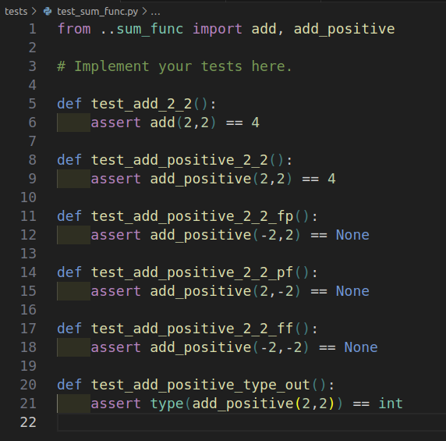

And the result is.

